PRACTICAL-9
Language recongnization using finite state automata and finite state machine

Context-Free Grammar (CFG) and Parsing

A Context-Free Grammar (CFG) is a formal way to describe the structure or syntax of languages. It consists of production rules that show how sentences are formed using terminals (words) and non-terminals (phrases).
Each rule defines how symbols can be replaced to generate valid strings in the language.
A parser like ChartParser in NLTK uses these rules to analyze whether a sentence follows the grammar and constructs a parse tree that shows the hierarchical relationship among words.
CFGs are widely used in natural language processing (NLP), compiler design, and syntax checking.

Example:
S → NP VP means a sentence is made up of a noun phrase followed by a verb phrase.

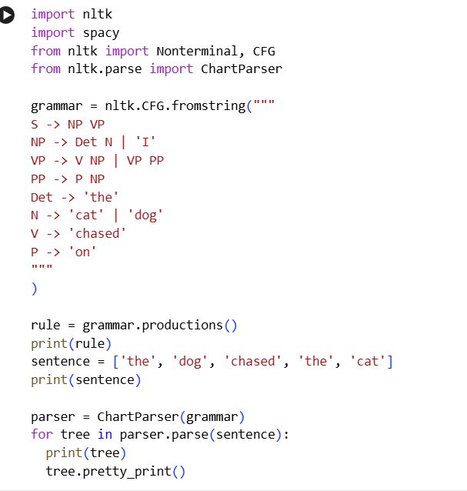
Code:

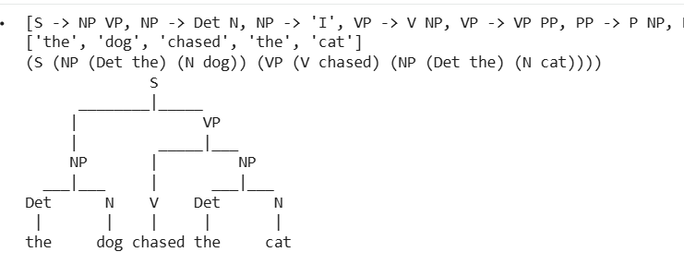
Output:

2. Finite Automata (DFA)
A Deterministic Finite Automaton (DFA) is a mathematical model used to recognize regular languages. It consists of a finite number of states, an input alphabet, transitions, a start state, and one or more final (accepting) states.
The DFA reads an input string symbol by symbol and changes states according to its transition function.
If the machine ends in a final state after reading the entire input, the string is accepted, otherwise rejected.
In your code, the DFA accepts all strings that start with the letter ‘a’.
Applications:
Lexical analysis, pattern recognition, and string validation in compilers and text processing.
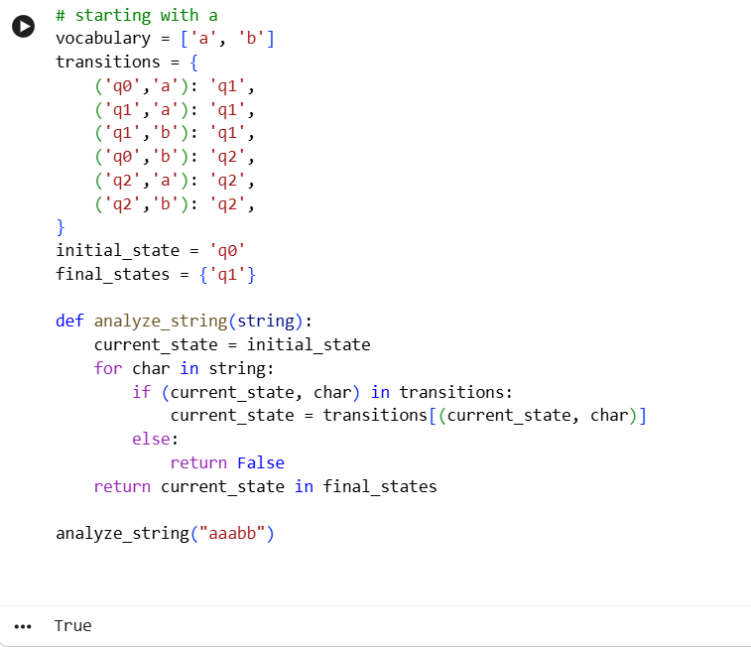
Code:

Mealy Machine
A Mealy Machine is a type of finite state machine where the output depends on both the current state and the input symbol.
Each transition is labeled with both an output and the next state — (next_state, output).
It is often used in digital circuit design, sequence detectors, and controllers.
In your implementation, the Mealy machine processes a binary string and produces outputs at each step. The final output represents the remainder when the binary number is divided by 3 (i.e., computing %3).
Key difference from Moore Machine:
- Mealy: Output depends on state + input
- Moore: Output depends only on state
Code:

